Zoom How-To for MPH Students Public Health Day 2021

This guide includes instructions and screenshots that might differ slightly based on what operating system you are using and whether you are using the Zoom app or using it in the browser. Ultimately, Zoom is very straightforward and easy to use. This guide is mainly provided to show you the process for Public Health Day, more than it is provided to teach you how to use Zoom.

Overview
Prior to the presentation:
- Test out your computer equipment. Select a quiet and distraction-free location for you to present from.
- Email a copy of your presentation to Emma Hunniford (emmahunniford@ufl.edu).
- Practice your presentation to ensure it is in the time limit (20 minutes for poster presentations, 15 minutes for oral presentations). Prepare any notes.
Day of the presentation:
- Test your computer equipment one last time.
- Turn off anything that may make noise and cause a distraction.
- Join the Zoom conference at least 5 minutes prior to the start time. Be sure to enable your microphone and webcam.
- Share your presentation.
- Present your final presentation, taking care to follow the time limit. Use the annotation tools if needed. If you are giving an oral presentation, continue with the Q & A portion.
- Celebrate completing your Public Health Day presentation!

Details
Prior to Presentation
- Check your computer equipment to ensure that everything will work properly for your presentation. You can test your microphone and webcam beforehand by following the steps here.
  - You will need to have a strong Internet connection for the presentation. If you find that your Wi-Fi is weak or spotty, you should look into a hard-wired Ethernet option. If you share Wi-Fi with other users (i.e. roommates, family), ask that they avoid using heavy bandwidth (i.e. downloads, streaming) during your presentation time.
  - If you have a laptop with integrated webcam and microphone, this should be fine to use. You are not required to use headphones or a separate microphone.
- Select a location you will sit at for your final presentation. This should be a well-lit area with no distractions. If you are presenting from a location with pets or other people, you should find an area away from them. Your webcam should be positioned to show your face and torso/shoulders. The lighting should be clear but should not distort or wash out the image. Natural lighting is a great option—just make sure that windows are in front of you, rather than directly behind you. Remember: this is a professional presentation. Take stock of your surroundings and remove anything that is unprofessional or distracting.
- If you have not used Zoom for a presentation before, it is recommended that you email Emma Hunniford (emmahunniford@ufl.edu) to arrange a short practice session. This will allow you to practice sharing your screen and presentation and become familiar with the Zoom set-up and controls.
- Poster presentations should be saved as a PDF. It is recommended that oral presentations be saved in a PowerPoint format. Consult with your faculty advisor about your presentation and make any necessary changes before finalizing. Once the presentation is finalized, email a copy to Emma Hunniford (emmahunniford@ufl.edu). (Note: For Fall 2021, only PHC 6601 students have the option of completing a poster presentation, with permission of the course instructor.)
- Be sure to practice the entire presentation. If you need to make any notes to refer to for the presentation, do so. When you share your presentation through Zoom, it will likely be full screen (especially PowerPoints in presenter mode). You will most likely not be able to view any digital notes that you have made through PowerPoint. If you would like to have notes or a script during your presentation, please plan to access these through a means other than your computer. If you have a second monitor, that would be accessible for notes. Other options include having printed notes, or having notes pulled up on a secondary device. Pay attention to these specifications, depending on how you are presenting:
  - Poster presentations- You are allotted 20 minutes for the entire presentation. This time is open to questions from both faculty reviewers. You should be sure to point out specific sections or data points that are most notable.
  - Oral presentations- You are allotted 15 minutes for the presentation. This is straight-through and uninterrupted, without feedback from faculty reviewers. After the 15 minutes conclude, there will be 5 minutes total allotted for Q & A from both reviewers. You should make sure that you can complete all slides in the allotted 15 minutes.
- You will be given a Zoom link to join for your final presentation. Be sure to save this.
Day of Presentation
- Silence anything in your area that may make noise during your presentation. This includes phones, computer updates, email notifications, alarms, and/or appliances. You might need to update your computer settings to disable updates or notifications. If you have any pets, you should make sure that they won’t interrupt your presentation. You may need to have them or yourself in a closed room, depending on their personality.
- Be sure that you are dressed professionally. Do a once-over of your presentation location to make sure that everything is suitable. It is recommended that you check your equipment one more time before you present.
- You will be able to join the Zoom conference prior to its start time. You should do this at least 5 minutes prior to the start time, so that you can set up your presentation. Once you are ready, enter the provided Zoom link into your browser. Once you join the conference, this should pop up. Select ‘Open Zoom Meetings.’ If you have not used Zoom before, you may be prompted to enter how you would like your name to appear. This will default to your GatorLink username—it is recommended that you change this to your full name.
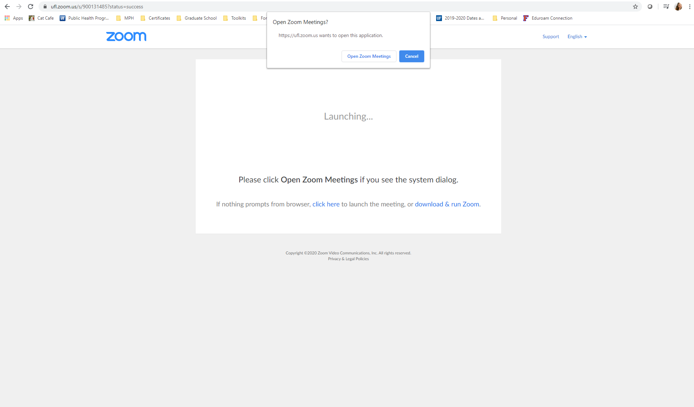
- If you have a webcam, you may be prompted to ask if you would like to join with video. Select ‘Join with Video.’ Note that this will share your webcam immediately once you join the conference. You should be prepared, just in case participants are already in the conference. Make sure you are already appropriately dressed and located.
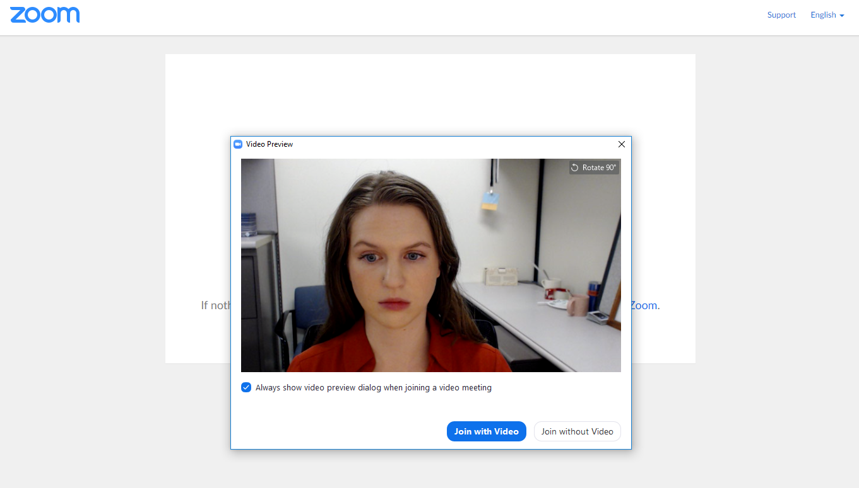
- The conference will be set up so that you will be muted upon joining. You will need to enable your microphone. You can do this in the bottom left corner of the screen by selecting the microphone icon.
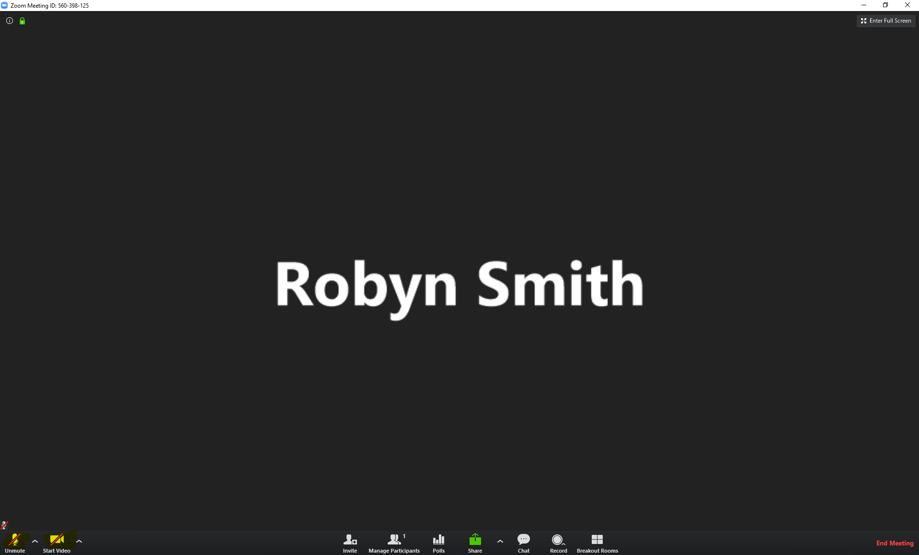
  - If you need to test your speakers and microphone, you can also do this here. Select the carrot symbol (^) next to the microphone option and select ‘Test Speakers & Microphone.’ If you are experiencing any technical difficulties, you can also switch audio inputs here by changing to phone audio.
- You should now set up your presentation. The best way to present through Zoom is through screen sharing. If you have not already, open your presentation on your computer. Select the green ‘Share’ icon on the bottom toolbar. This will ask which screen or program you want to share. It is recommended that you just select the presentation rather than the whole screen (If you are presenting a poster, just select the PDF. If you are presenting orally, just select the PowerPoint). This will minimize the chance of any computer pop-ups or interruptions during your presentation. If you do not see your presentation, selecting ‘Show all windows…’ in the pop-up screen will show more options. Make sure that the ‘Share computer sound’ option is unchecked, to prevent any accidental computer sounds from coming through. If your PowerPoint presentation incorporates any sounds or video, you may leave this checked.
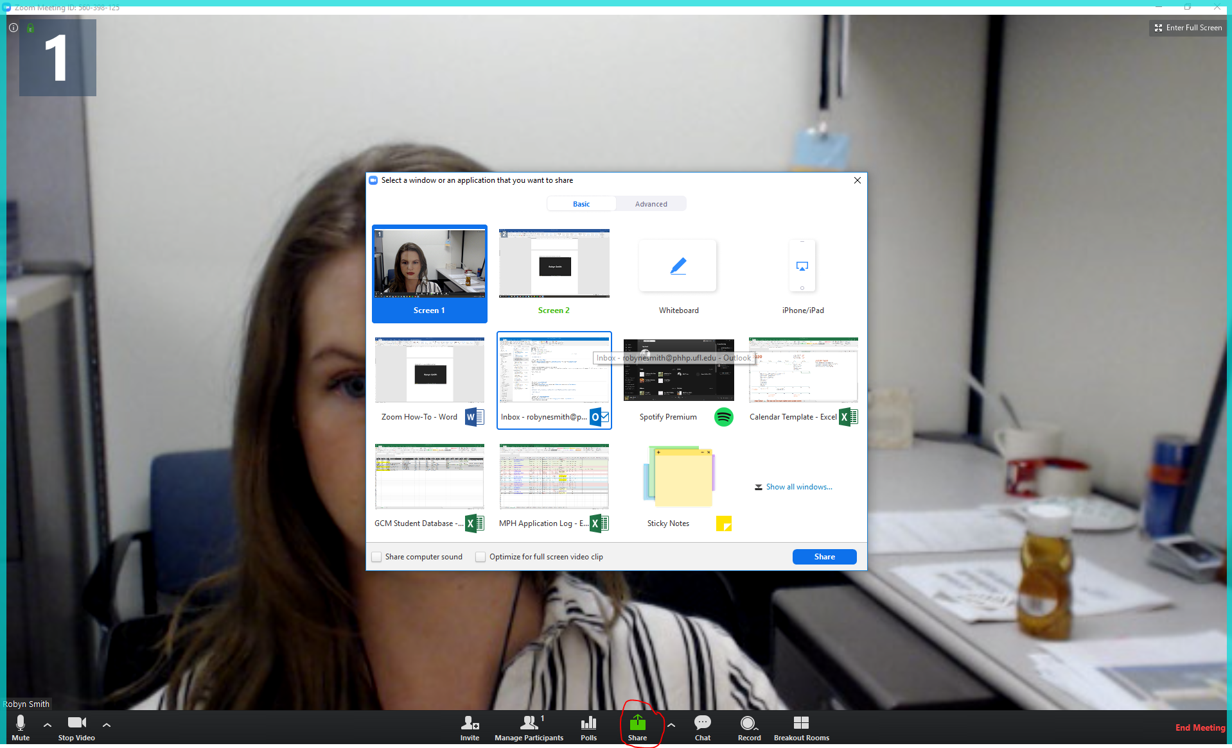
- Once you select your presentation file, it will be full screen on your computer and it will look as if you are no longer in Zoom. There will be a bar at the top of the screen to signal that you are still in Zoom, and you should see a small thumbnail of your webcam image. You can move this thumbnail to a portion of the screen that does not cover your presentation. The toolbar on the top will expand when you hover over it. This gives you the option to stop screen sharing, which should only be used at the end of the presentation.
  - Note that this is just how it appears to you, not how it appears to viewers. They will see your webcam image as a small box, next to whatever portion of the screen you shared with them. It will look similar to this:
Your Presentation
Your Webcam Thumbnail
  - If you would like to change the webcam view so that you see other participants, you can select the two bars on the thumbnail image (the blue ones highlighted here). If you just want to see the webcam image of whoever is speaking, you can select the single box.
Participant Name
  - Zoom also has integrated features for being able to draw on or point at the presentation with the ‘Annotate’ tab in the top toolbar. The default is ‘Mouse,’ which shows the normal cursor and should be used normally, as this is what will be needed to click on your screen (i.e. to start the presentation). Viewers can see this if you want to use the cursor to point out certain information or data points. ‘Draw’ gives the option to draw on slides, in the event you want to circle something or make note of something. ‘Spotlight’ acts similarly to a laser pointer. You do not have to use any of these, but they are an option. You may find them especially helpful for poster presentations, to point out specific sections.
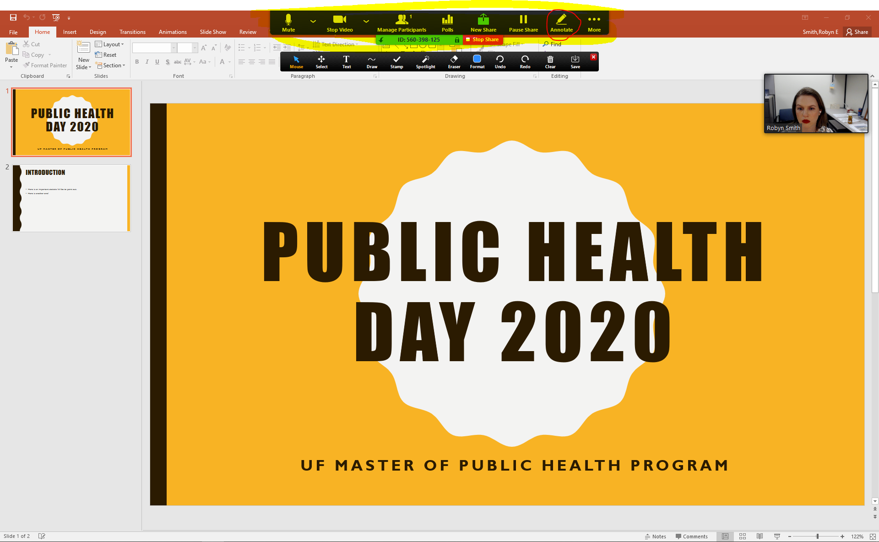
  - Relevant Help Articles from Zoom: Screen sharing, Screen sharing a PowerPoint presentation, Adjusting the layout of the screen while sharing, Using annotation tools during screen sharing
- You should have your presentation completely pulled up and ready by the official start time of your presentation. Note that you may be pulling this up and sharing it while other participants join the conference. They will also be muted but you may see them join via webcam or may engage with conversation once they enable their microphone. Of course, pleasantries are fine, just like they would be in person! Just be mindful of the time limit for the Zoom conference. The MPH staff member in the conference will be monitoring time and may let you know if you need to move to the presentation portion. The MPH staff member should ask if you would like a time warning during your presentation, to notify you that you are nearing the time limit. This is optional, as many students may prefer to keep time on their own timer. If you prefer to keep time yourself, be sure to ready your timer now. Once your presentation is shared and all participants are in the conference, the presentation portion will begin. The MPH staff member will be recording your presentation through Zoom as a record of completion. They will notify you when it is time to begin. Your faculty advisor may introduce you and your special project or may ask you to do so. If you asked for a time warning, the MPH staff member will send this via the ‘Chat’ function at the agreed upon time.
  - Poster presentations- You will have 20 minutes to present your poster. This will include feedback and questions from both faculty reviewers. You will need to walk the faculty reviewers through each section of the poster, stopping for questions as they come up.
  - Oral presentations- You will have 15 minutes to complete your PowerPoint presentation. This will be done in one take as it will be live—if there are any errors, just keep going. All participants will be instructed to disable their microphones during this portion to prevent distractions and interruptions.
- After the allotted time limit, the MPH staff member will alert you that the presentation portion is concluded. At this point, they will stop the recording.
  - Poster presentations- This concludes all requirements. You may wish to exchange any final pleasantries with the faculty reviewers and staff member, being mindful of the time. The MPH staff member will let you know that the meeting has ended and that you have finished with your Public Health Day presentation.
  - Oral presentations- There will now be 5 minutes allotted for Q & A. At this time, both faculty reviewers will enable their microphones again. The MPH staff member will monitor time to end the Q & A portion once 5 minutes has passed. They will alert you once the Q & A portion has ended. You may wish to exchange any final pleasantries with the faculty reviewers and staff member, being mindful of the time. The MPH staff member will let you know that the meeting has ended and that you have finished with your Public Health Day presentation.
- At this point, the MPH staff member will end the Zoom meeting, which will automatically end the conference for you.
- Be sure to log in to the Canvas course and upload your presentation for the Final Public Health Day Presentation assignment, if you have not already.
- And most importantly, celebrate! While we are sad that we are not able to recognize your accomplishments in person, the MPH program is happy to have you near the end of your program. You have put in a lot of work through the semesters and this project and presentation is a great culminating experience to celebrate that fact. Congratulations from all the MPH staff and all of the staff and faculty here at PHHP!

